CS 340 README

About the Project/Project Title
Built using pymongo, CRUD Python Module serves as a glue between MongoDB databases and web software.

Motivation
CRUD Python Module seeks to simplify CRUD function calls for web apps and act as a protective layer for the underlying database. This was made specifically for Grazioso Salvare but can be easily repurposed for other databases.

Getting Started
CRUD Python Module is simple to get started. As the user, simply download the files then open CRUD_Python_Module.py to configure the connection variables for your database.
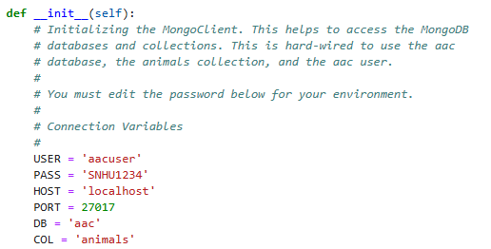
USER, PASS, HOST, PORT, DB, and COL should be updated to reflect your database (DB) and collection (COL), and your authentication details.
The create and read functions were created based on MongoDB documentation and were fairly simple to create. I would recommend anyone reconfiguring for a new database adjust the create and read functions from self.database.animals to self.collections.

Installation
This module relies on pymongo and objectId to function. Pymongo provides the basis for all CRUD functionality within with app, while objectId allows for use of the objectId type, which MongoDB uses for unique IDs. All the user needs is Python, as both requirements are already installed to the module.

Usage

Code Example
The module contains two functions, create and read.
create takes the input of a dictionary and inserts it into the configured database, returning True if the insert was successful and False if not.
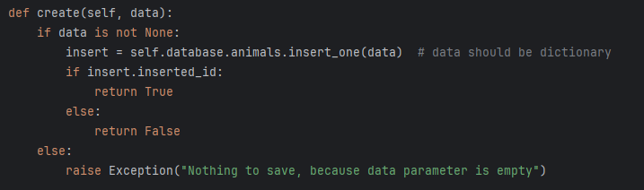

read takes the input of a dictionary, finds the matching document and prints it for the user.
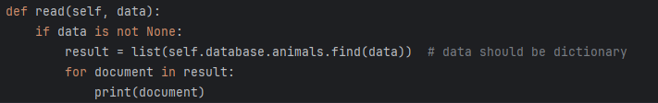

Tests
So far, I have only tested for basic functionality and shown that the module works with the configured animal shelter database. Here is an example of inserting an instance of a cat document into the database then reading it.

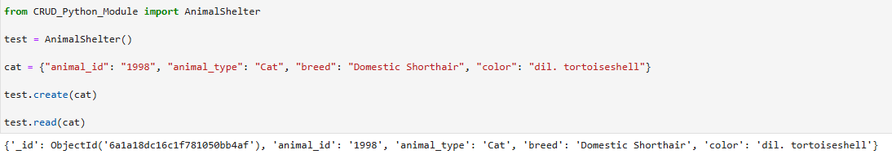

Roadmap/Features (Optional)
I plan to adjust the create and read functions to be more general, which will increase general usability. Delete and Update functions will also be added to complete CRUD functionality.

Contact
Your name: Cielo Neal

